Dear Parents,
We will be using Microsoft Teams to foster connection between students and teachers and remote learning instruction. Microsoft Teams is part of the Office 365 suite. Some students have already used Microsoft Teams to collaborate this year. To ensure everyone knows exactly where to go, we are sharing the following directions with you as well:
1. Login to Office 365 (portal.office.com)
2. Select the Teams icon through the waffle
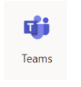
3. When students reach the Teams page, they will see icons for each of their classes. For my class, they will choose either “Romans Morning 2019-2020” or “Romans Afternoon 2019-2020” depending on which class they are in. (They will only see one of these options)
4. When they select class, they will see the hub for their remote learning environment. The Team will look something like this:
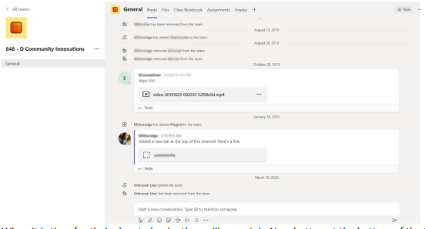
5. When it is time for their class to begin, they will see a Join Now button at the bottom of the Posts Tab when their teacher begins the call.
6. Students will select that Join Now button, and they will then see their teacher!

